Overview
Building an IoT device and system is a valuable skill for IT professionals. IoT devices can collect and monitor a continuous stream of data, for example, a smart thermostat that tracks room temperature and adjusts settings automatically. They can also enable remote control and monitoring, such as a wearable heart monitor that transmits real-time data to a doctor or a device that monitors a production line process and checks for and records data about product defects. IoT systems improve operational efficiency, send alerts when specific conditions are met, and help create connected experiences and smart ecosystems.
In this lab, you will set up a database server surrogate (SQLite file) and build an IoT device and system. In order to use SQLite in Node-RED, you must install the node-red-node-sqlite using the Node-RED SetupTutorial linked in the Supporting Materials section below.

Directions
To complete this lab, launch the Node-RED environment in uCertify. See the Node-RED Setup Tutorial linked in the Supporting Materials section below for guidance. Note: The Node-RED environment is not persistent. If you cannot complete the lab in one session, you must export your progress to a cloud drive before leaving the environment and import it when you return.
After launching the Node-RED environment, complete the lab using the following steps:
- Create a test database for your first Node-RED assignment. You can use the following SQL code to create the table and the SQLite file that will contain your database:
CREATE TABLE `basic` ( `ID` integer NOT NULL PRIMARY KEY AUTOINCREMENT, `stamp` int(11) NOT NULL );
INSERT INTO `basic` (`ID`, `stamp`) VALUES (1, 22), (2, 44);
- Create a Write Flow.
  - Use an Inject node to manually trigger the flow.
  - Add static data—for example, name, temperature, timestamp—in the Inject node.
  - Connect it to an SQLite node to insert the data into your database.
  - End the flow with a Debug node to confirm the data was successfully written.
- Create a Read Flow.
  - Create a new flow that uses an SQLite node to query the database.
  - Retrieve the data you inserted in Step 1.
  - End this flow with a Debug node to display the results.
- Capture your output.
  - Use the uCertify screenshot tool to take a screenshot of the output in the Debug window showing the returned data.
  - Download the screenshot and insert it into a Microsoft Word document for submission to Brightspace.
- Export your flow.
  - Export your Node-RED flow as a JSON file.
  - Copy and paste the exported JSON file’s contents into the same Microsoft Word document as the Debug screenshot and submit to Brightspace.
Specifically, you must address the following rubric criteria:
- Database Table: Create a table in the database.
- Table Fields: Create a field in the new table.
- Write Data: Create a flow that writes data to the database.
- Read Data: Create a flow that reads the previously created data from the database.
- Export Flow: Export the JSON file for the flows that you built and tested.

Photo 1:
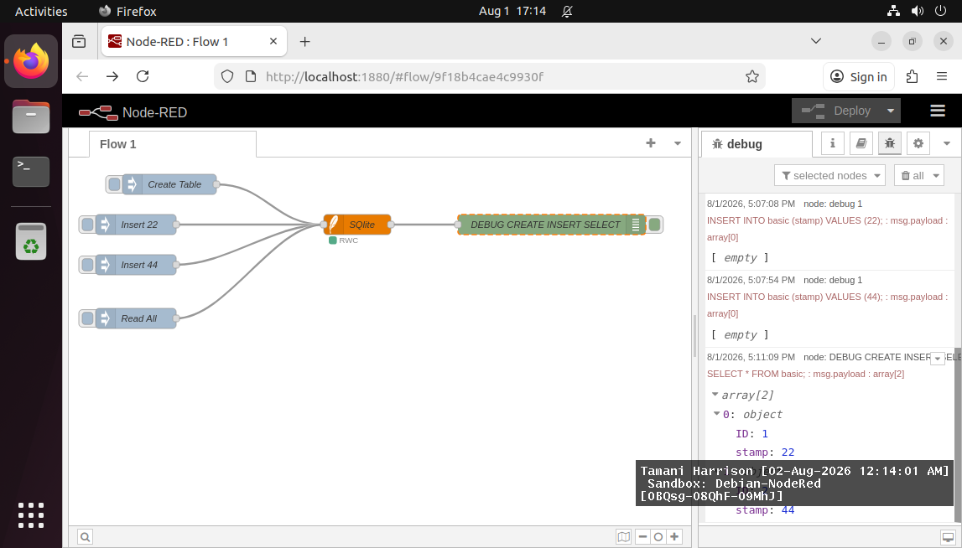
Part of the object list is obscured, so here is another snapshot.
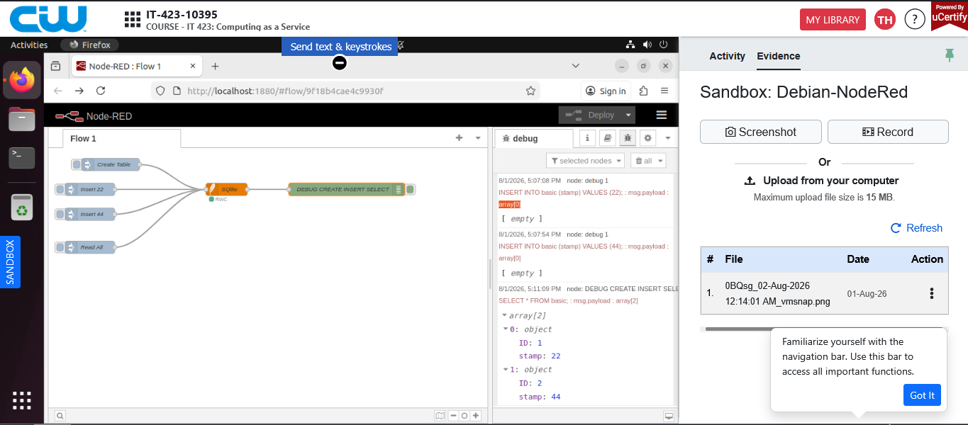
JSON:
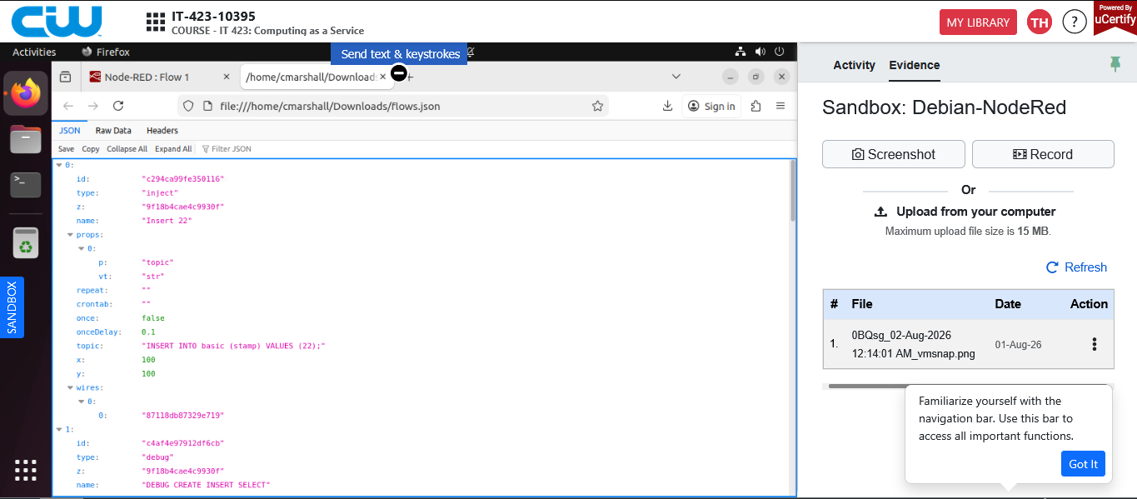
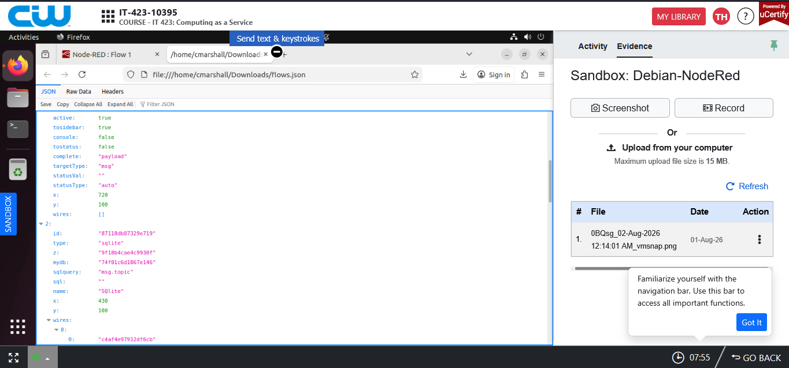
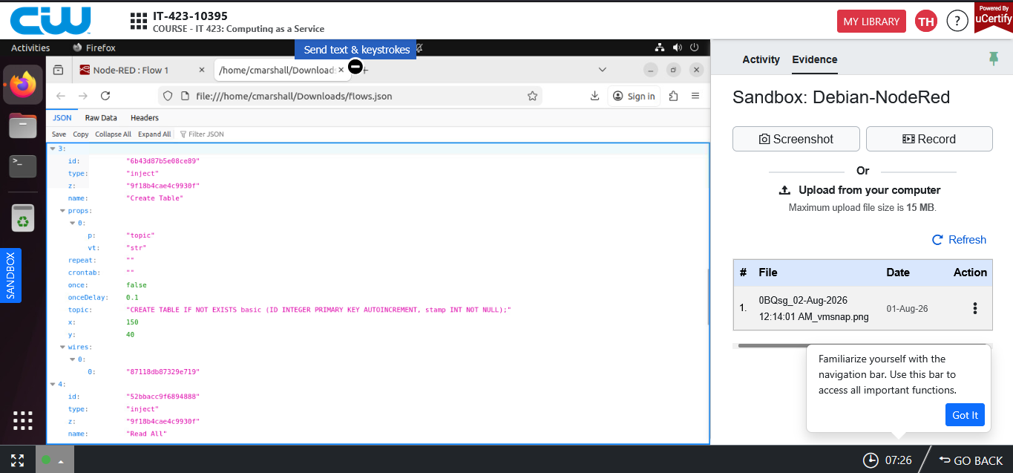
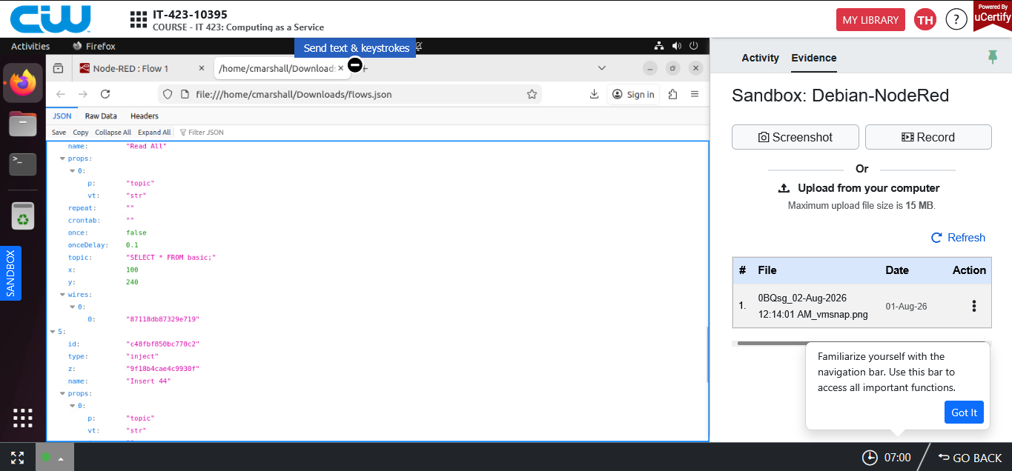

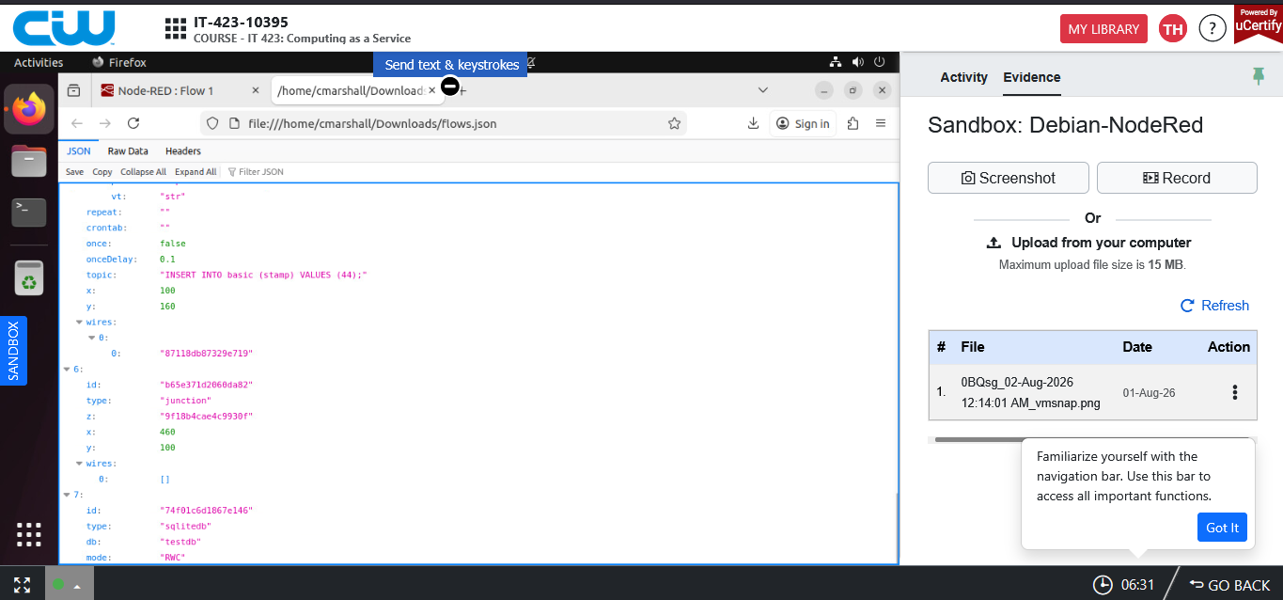

[
{
"id": "c294ca99fe350116",
"type": "inject",
"z": "9f18b4cae4c9930f",
"name": "Insert 22",
"props": [
{
"p": "topic",
"vt": "str"
}
],
"repeat": "",
"crontab": "",
"once": false,
"onceDelay": 0.1,
"topic": "INSERT INTO basic (stamp) VALUES (22);",
"x": 100,
"y": 100,
"wires": [
[
"87118db87329e719"
]
]
},
{
"id": "c4af4e97912df6cb",
"type": "debug",
"z": "9f18b4cae4c9930f",
"name": "DEBUG CREATE INSERT SELECT",
"active": true,
"tosidebar": true,
"console": false,
"tostatus": false,
"complete": "payload",
"targetType": "msg",
"statusVal": "",
"statusType": "auto",
"x": 720,
"y": 100,
"wires": []
},
{
"id": "87118db87329e719",
"type": "sqlite",
"z": "9f18b4cae4c9930f",
"mydb": "74f01c6d1867e146",
"sqlquery": "msg.topic",
"sql": "",
"name": "SQlite",
"x": 430,
"y": 100,
"wires": [
[
"c4af4e97912df6cb"
]
]
},
{
"id": "6b43d87b5e08ce89",
"type": "inject",
"z": "9f18b4cae4c9930f",
"name": "Create Table",
"props": [
{
"p": "topic",
"vt": "str"
}
],
"repeat": "",
"crontab": "",
"once": false,
"onceDelay": 0.1,
"topic": "CREATE TABLE IF NOT EXISTS basic (ID INTEGER PRIMARY KEY AUTOINCREMENT, stamp INT NOT NULL);",
"x": 150,
"y": 40,
"wires": [
[
"87118db87329e719"
]
]
},
{
"id": "52bbacc9f6894888",
"type": "inject",
"z": "9f18b4cae4c9930f",
"name": "Read All",
"props": [
{
"p": "topic",
"vt": "str"
}
],
"repeat": "",
"crontab": "",
"once": false,
"onceDelay": 0.1,
"topic": "SELECT * FROM basic;",
"x": 100,
"y": 240,
"wires": [
[
"87118db87329e719"
]
]
},
{
"id": "c48fbf850bc770c2",
"type": "inject",
"z": "9f18b4cae4c9930f",
"name": "Insert 44",
"props": [
{
"p": "topic",
"vt": "str"
}
],
"repeat": "",
"crontab": "",
"once": false,
"onceDelay": 0.1,
"topic": "INSERT INTO basic (stamp) VALUES (44);",
"x": 100,
"y": 160,
"wires": [
[
"87118db87329e719"
]
]
},
{
"id": "b65e371d2060da82",
"type": "junction",
"z": "9f18b4cae4c9930f",
"x": 460,
"y": 100,
"wires": [
[]
]
},
{
"id": "74f01c6d1867e146",
"type": "sqlitedb",
"db": "testdb",
"mode": "RWC"
}
]

